## Slide deck pitch

**1 States matter when looking at the fiscal position**

Since the 2008 Global Financial Crisis Australian government finances have gradually deteriorated, with net debt increasing by 24% of GDP. Up until the COVID pandemic this was predominantly driven by Federal borrowing. However, post-COVID State debt has risen considerably – growing from 2% of GDP to 12.8% by 2025.

At a consolidated level – where both State and Federal government budgets are combined – the fiscal position looks set to worsen over coming years, with rising State debt expected to push consolidated net debt above its pandemic highs. By 2029 State borrowing is forecast to account for 42% of general government net debt.

Figure 1

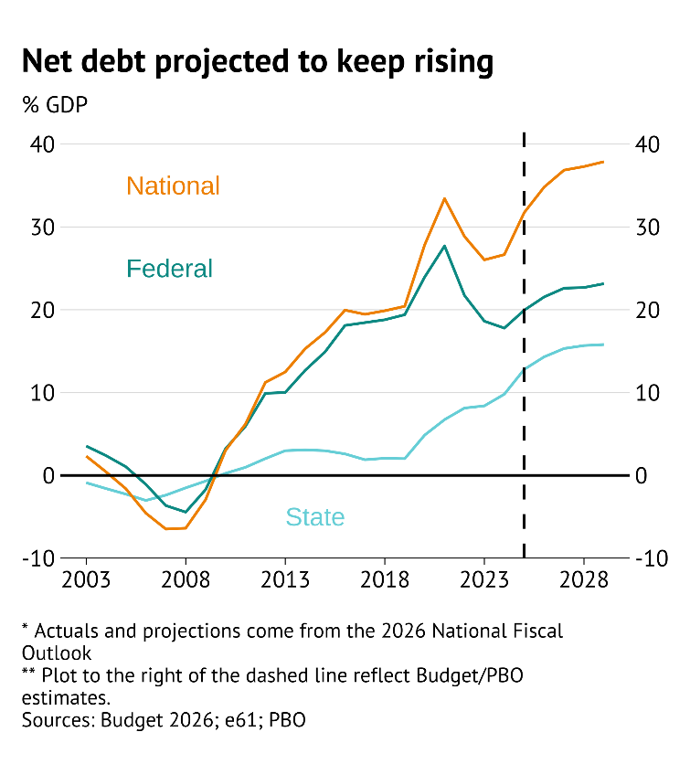

**2 Spending is elevated without the tax capacity to catchup**

Consolidated government expenses were estimated to be 36.2% of GDP in the 2025 financial year, its highest level since 2022 when some COVID expenditures were still in place. Government revenue has failed to keep pace with this spending, with an estimated 34.6% of GDP raised.

Government forecasts anticipate a decline in expenses relative to GDP over the next decade which is forecast to, alongside rising revenue from bracket creep, close the fiscal gap. However, if expenses continue to follow demographic trends continuing general government deficits are likely.

Figure 2

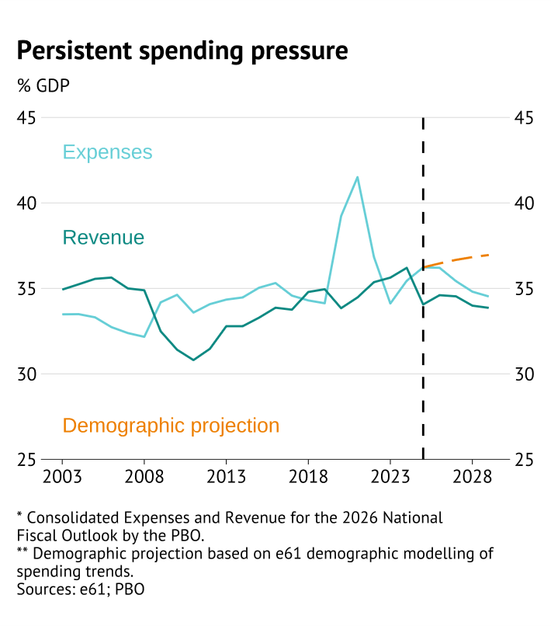

**Interest burden will limit fiscal headroom**

Rising government debt is pushing up expenditure on public debt interest even as interest rates have remained reasonably low. By 2025 Federal interest burdens are estimated to have risen to 0.9% of GDP, their highest level since 2000.

However, once the interest burden on state debt is included total expenditure rises to around 1.5% of GDP. This is equivalent to over three quarters of current defence spending, or 30% of public education expenditure. By 2029 interest expenses are expected to rise to 2.1% of GDP even if interest rates do not rise – higher than individual expenditure on defence, public order and safety, and economic affairs.

Figure 3

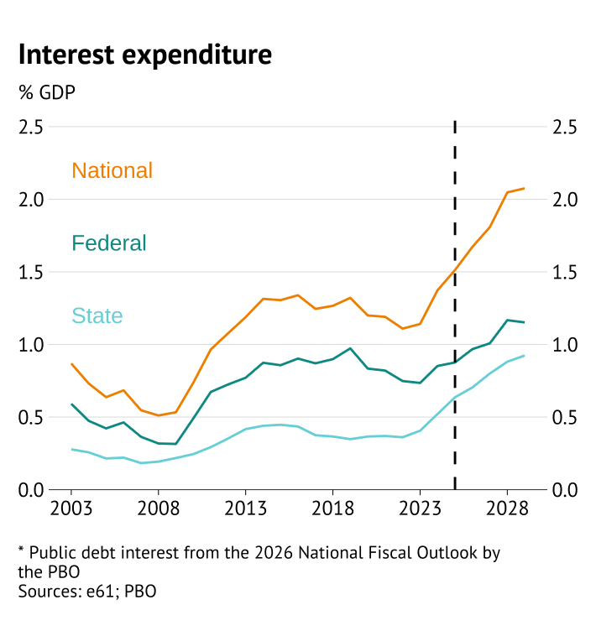

**Other countries provide a warning about where this can go**

In the early 1990s general government debt in Australia was roughly similar to other high-income countries. However, since that time net debt has risen considerably across the OECD – increasing above 100% of GDP in Japan, France, and the United States while nearing 100% in the UK.

Although it may seem these other countries have had less fiscal discipline than Australia, all of them except for the United States have experienced earlier and more rapid population ageing. Around 15.8% of the Australian population is aged over 65, compared to 18.3% in the UK, 20.3% in France, and 28.2% in Japan. The difficulty that these countries have had in containing government debt as the population has aged and public pressure on spending has climbed points to potential future risks for the Australian government fiscal position.

Figure 4

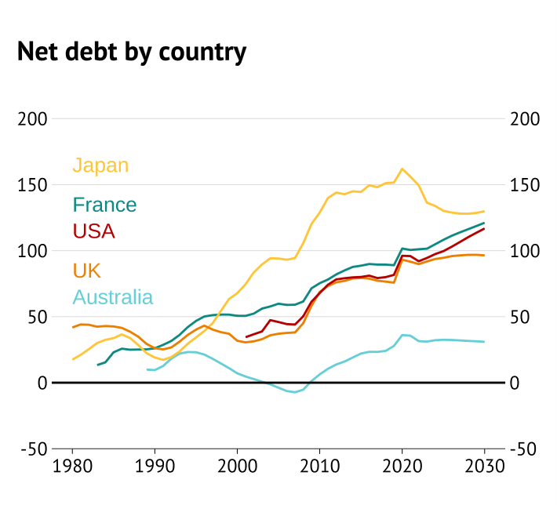

**Ageing will continue to place upward pressure on spending**

A central driver of fiscal difficulties from population ageing is spending on health care. Given demographic trends, government expenditure on health services is expected to rise from 7.6% currently to nearly 10% of GDP by 2060. These estimates suggest relative restraint in health spending relative to comparison countries (i.e. New Zealand, the United States).

However, although this is the most stark increase in spending due to ageing, additional cost pressures on the aged pension, aged care, and reduced tax revenue due to rising dependency ratios are all factors that will combine to mechanically make the fiscal position more precarious.

Figure 5

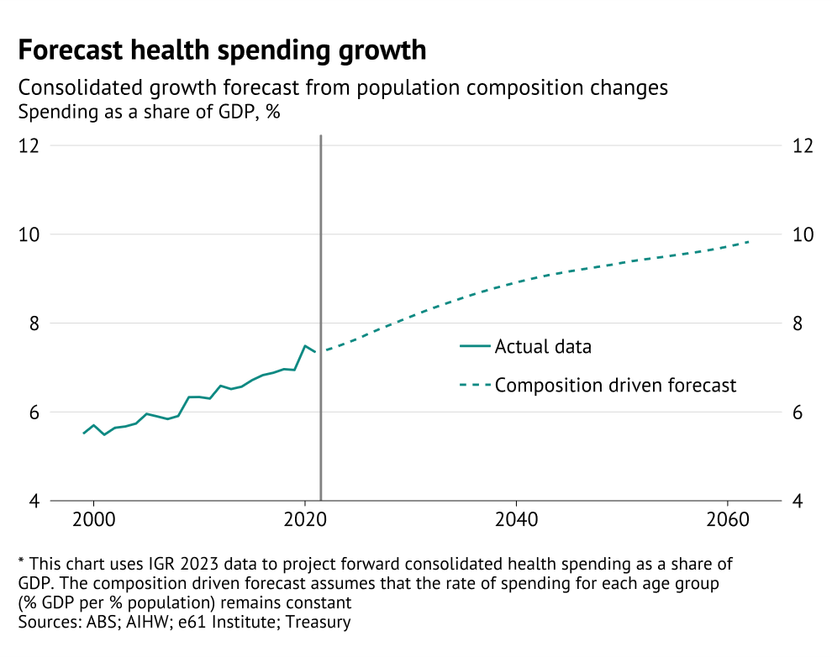

**New pressures and priorities have a fiscal cost**

However, government decisions also play into the fiscal sustainability story. Since 2016, the government has increased per person expenditure on education and non-income based social support. The introduction of NDIS, increased generosity of child-care subsidies, and post-Gonski increases in education spending were all large policy choices that have used up fiscal space.

Based on ageing alone expenditure on education and family supports would shrink as a share of government expenditures and GDP – as the share of the population that needs to receive these supports declines. However, over the past decade the government has not banked the gains from these programs – and instead found ways to increase and universalise supports in order to maintain spending.

Figure 6

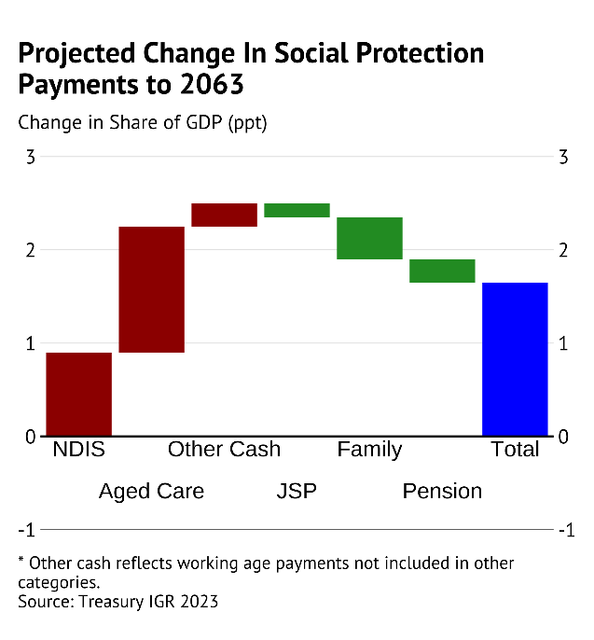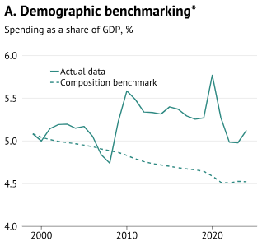

**Under current fiscal habits the outlook is for more debt**

Based on demographic trends government expenditure relative to GDP is expected to rise over the next decade. In current spending habits persist we expect consolidated government spending to reach 38% of GDP in 2035. Given moderate economic growth gross debt will stablise around 50-60% of GDP over the next two decades. However, with ageing pressures continuing to worsen gross debt is then expected to rise further in the longer-term.

Figure 7

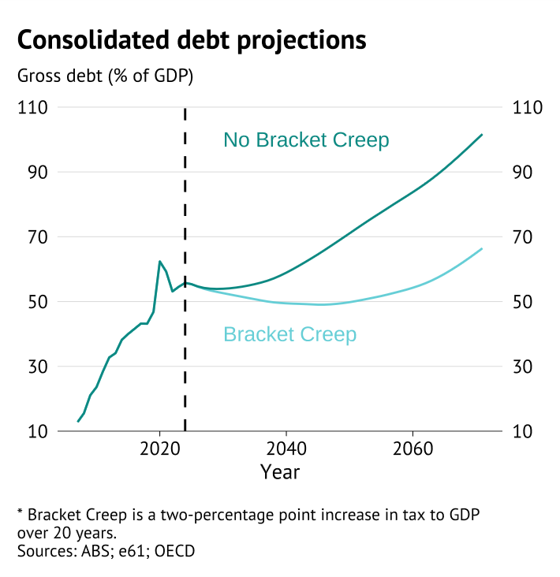

This outlook deteriorates when including an assessment of possible economic shocks. The risky economic environment generates risks to government spending and revenue that could lead the Federal debt position to deteriorate rapidly. Even if the fiscal position does not deteriorate due to these shocks, the increase in Federal debt would increase gross debt over 80% of GDP in the most negative scenario.

Figure 8

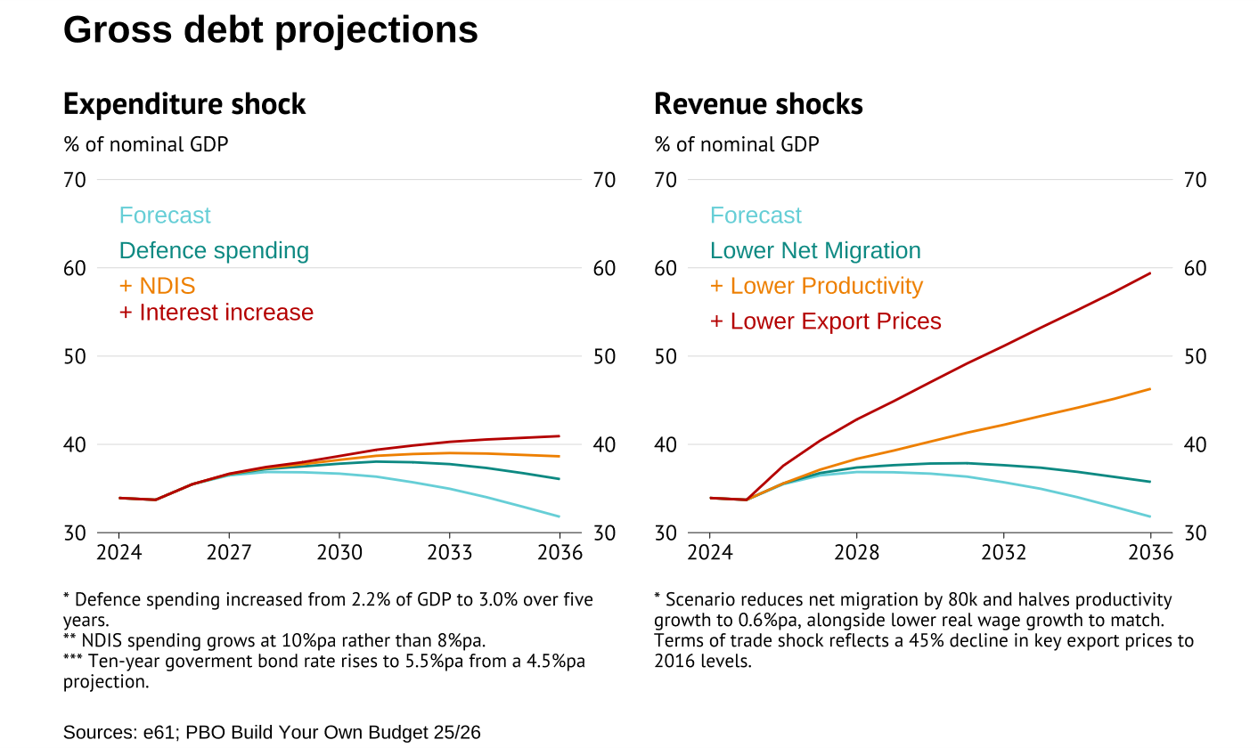

**Tax increase or spending restraint needed to balance the long-term budget**

Figure 9

